**JavaScript Form Validation for Registration Page**

**EXP NO: 2**

**AIM:**

Write JavaScript to validate the following fields of the Registration page.

1. First Name (Name should contains alphabets and the length Should not be less than 6 characters).
2. Password (Password should not be less than 6 characters length).
3. E-mail id (should not contain any invalid and must follow the standard pattern [name@domain.com)](mailto:name@domain.com)
4. Mobile Number (Phone number should contain 10 digits only).
5. Last Name and Address (should not be Empty).

# CODE:

**Validate.html**

<!DOCTYPE html>

<html>

<head>

<title>Registration Form</title>

<style>

body {

font-family: Arial, sans-serif; background-color: #f2f2f2; display: flex;

flex-direction: column; align-items: center; padding: 20px;

}

form {

background-color: white; padding: 20px;

padding-right: 30px; border-radius: 10px;

box-shadow: 0 0 10px rgba(0,0,0,0.1); width: 320px;

}

label {

font-weight: bold;

}

input, textarea { width: 100%; margin-top: 5px;

margin-bottom: 10px; padding: 8px;

border: 1px solid #ccc; border-radius: 6px;

}

.error-message { color: red;

font-size: 13px; margin-bottom: 10px;

}

input[type="submit"] { background-color: #4CAF50; color: white;

cursor: pointer; font-weight: bold; border: none;

}

input[type="submit"]:hover { background-color: #45a049;

}

h1 {

margin-bottom: 20px;

}

</style>

</head>

<body>

<h1>Registration Form</h1>

<form name="RegForm" onsubmit="return validateForm()">

<label for="firstname">First Name:</label>

<input type="text" id="firstname" name="firstname" required>

<span id="firstname-error" class="error-message"></span>

<label for="lastname">Last Name:</label>

<input type="text" id="lastname" name="lastname" required>

<span id="lastname-error" class="error-message"></span>

<label for="password">Password:</label>

<input type="password" id="password" name="password" required>

<span id="password-error" class="error-message"></span>

<label for="email">Email:</label>

<input type="text" id="email" name="email" required>

<span id="email-error" class="error-message"></span>

<label for="phone">Phone Number:</label>

<input type="tel" id="phone" name="phone" required>

<span id="phone-error" class="error-message"></span>

<label for="address">Address:</label>

<textarea id="address" name="address" required></textarea>

<span id="address-error" class="error-message"></span>

<input type="submit" value="Submit">

</form>

<script>

function validateForm() { let isValid = true;

let firstname = document.getElementById("firstname").value.trim(); let lastname = document.getElementById("lastname").value.trim(); let password = document.getElementById("password").value;

let email = document.getElementById("email").value.trim(); let phone = document.getElementById("phone").value.trim();

let address = document.getElementById("address").value.trim();

const firstnameError = document.getElementById("firstname-error"); const lastnameError = document.getElementById("lastname-error"); const passwordError = document.getElementById("password-error"); const emailError = document.getElementById("email-error");

const phoneError = document.getElementById("phone-error"); const addressError = document.getElementById("address-error");

firstnameError.textContent = ""; lastnameError.textContent = ""; passwordError.textContent = ""; emailError.textContent = ""; phoneError.textContent = ""; addressError.textContent = "";

if (!/^[A-Za-z]{6,}$/.test(firstname)) {

firstnameError.textContent = "First Name must be alphabetic and at least 6 characters."; isValid = false;

}

if (lastname === "") {

lastnameError.textContent = "Last Name should not be empty."; isValid = false;

}

if (password.length < 6) {

passwordError.textContent = "Password must be at least 6 characters."; isValid = false;

}

const emailPattern = /^[a-zA-Z0-9._%+-]+@[a-zA-Z0-9.-]+\.[a-zA-Z]{2,}$/; if (!emailPattern.test(email)) {

emailError.textContent = "Invalid email format (e.g., [name@domain.com).](mailto:name@domain.com)"; isValid = false;

}

if (!/^\d{10}$/.test(phone)) {

phoneError.textContent = "Phone number must be exactly 10 digits."; isValid = false;

}

if (address === "") {

addressError.textContent = "Address should not be empty."; isValid = false;

}

if (isValid) {

alert("Registered successfully!");

}

return isValid;

}

</script>

</body>

</html>

# OUTPUT:

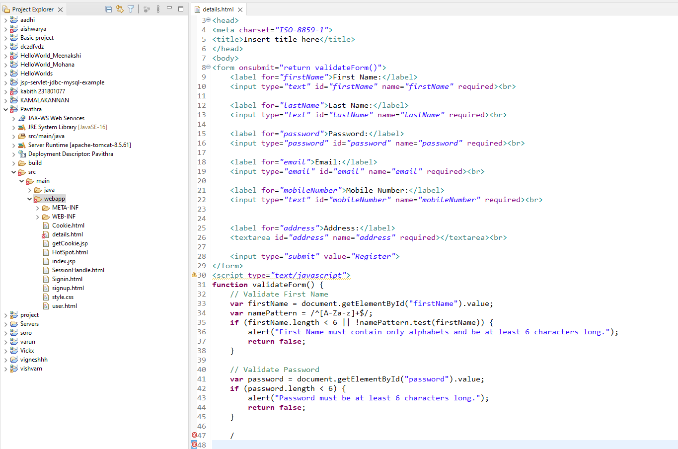

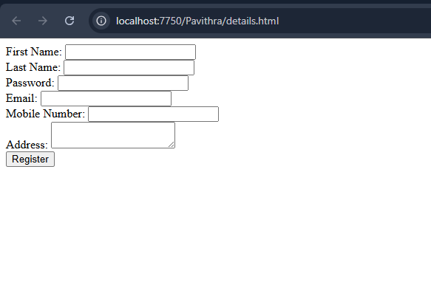

**RESULT:**

The Registration form with required validation is successfully implemented.